During Kharif Season 2022-23 Progress of sowing and agricultural crops Details.
(26.08.2022)

2022-23 Agricultural Production:

Anticipating timely and well distributed rainfall during pre-monsoon, southwest & northeast monsoon period in 2022-23 it was programmed to cover 82.67 lakh hectares, 26.68 lakh hectares and 5.20 lakh hectares during Kharif, Rabi and Summer seasons respectively, totally 114.54 lakh hectares under agricultural crops. Proposed production target for Food grains and Oilseeds were 148.02 lakh tonnes and 12.69 lakh tonnes respectively.

Sl.No. | Crops | Area (Lakh Hectares) | Production (Lakh Tonnes)
1. | Cereals | 50.45 | 123.06
2. | Pulses | 35.14 | 24.96
 | Total Food Grains | 85.59 | 148.02
3. | Oilseeds | 12.64 | 12.69
4. | Commercial Crops
i) | Cotton | 7.70 | 18.75 Lakh Bales
ii) | Sugarcane | 7.87 | 403.57
iii) | Tobacco-VFC | 0.75 | 0.66
 | -Beedi | 0.00 | 0.00
 | Total Area | 114.54

2022-23 Kharif Agricultural Production:

During Kharif 2022 total of 82.67 lakh hectares area has been set as target for sowing under different crops.
Sl.No. | Crops | Area (Lakh Hectares) | Production (Lakh Tonnes)
1. | Cereals | 35.98 | 97.61
2. | Pulses | 22.77 | 17.19
 | Total Food Grains | 58.75 | 114.80
3. | Oilseeds | 9.37 | 8.70
4. | Commercial Crops
i) | Cotton | 7.28 | 18.42 Lakh Bales
ii) | Sugarcane | 6.51 | 377.99
iii) | Tobacco-VFC | 0.75 | 0.66
 | -Beedi | 0.00 | 0.00
 | Total Area | 82.67

During pre-monsoon period between April to May in view of agricultural activities in the state, districts such as Chamarajanagara, Mandya, Hassan, Chikkamangaluru, Tumkur, Koppal, Ramanagara, Mysuru and Chitradurga at various places land preparation as been done and till 27.05.2022 total of 3.18 lakh ha. area as been sown under jowar, greengram, blackgram, cowpea, sesamum, sunflower, cotton, etc.

In Coastal, Malnad, South Interior Karnataka and North Interior Karnataka region, after south west monsoon commenced land preparation and sowing activities have been started.

Rainfall:
Pre-monsoon Rainfall:

March-1 to May-31 normal rainfall was 115 mm against actual rainfall 237 mm (105 %).

June-1 to August-26 normal rainfall was 666 mm against actual rainfall 775 mm (16%). District wise rainfall data is attached in Annexure-1.

Kharif 2022 Area coverage:
During Early Kharif 2022 total of 3.18 lakh hectares (113%) has been sown against a set target of 2.80 lakh hectares by 27.05.2022.

During Kharif 2022 total of 74.37 lakh hectares (90%) has been sown against a set target of 82.67 lakh hectares by 26.08.2022, Crop-wise and district-wise area sown details was provided in annexure 2 and 3.

Seeds:

For Kharif 2022-23, 5.38 lakh qtls seeds were estimated as demand for sowing and till dated: 26.08.2022, 3.92 lakh qtls seeds have been distributed at Raitha Samparka Kendra (RSK). Remaining balance of 80063.30 qtls stock is available at RSK .

Fertilizer:

For Khrif 2022-23, total fertilizer demand was estimated at 26.76 lakh metric tonnes and arrangement has been made for timely implementation at various stages till 26.08.2022 total of 20.58 lakh metric tonnes fertilizer as been supplied and the available stock is 5.97 lakh metric tonnes.

Annexure-1
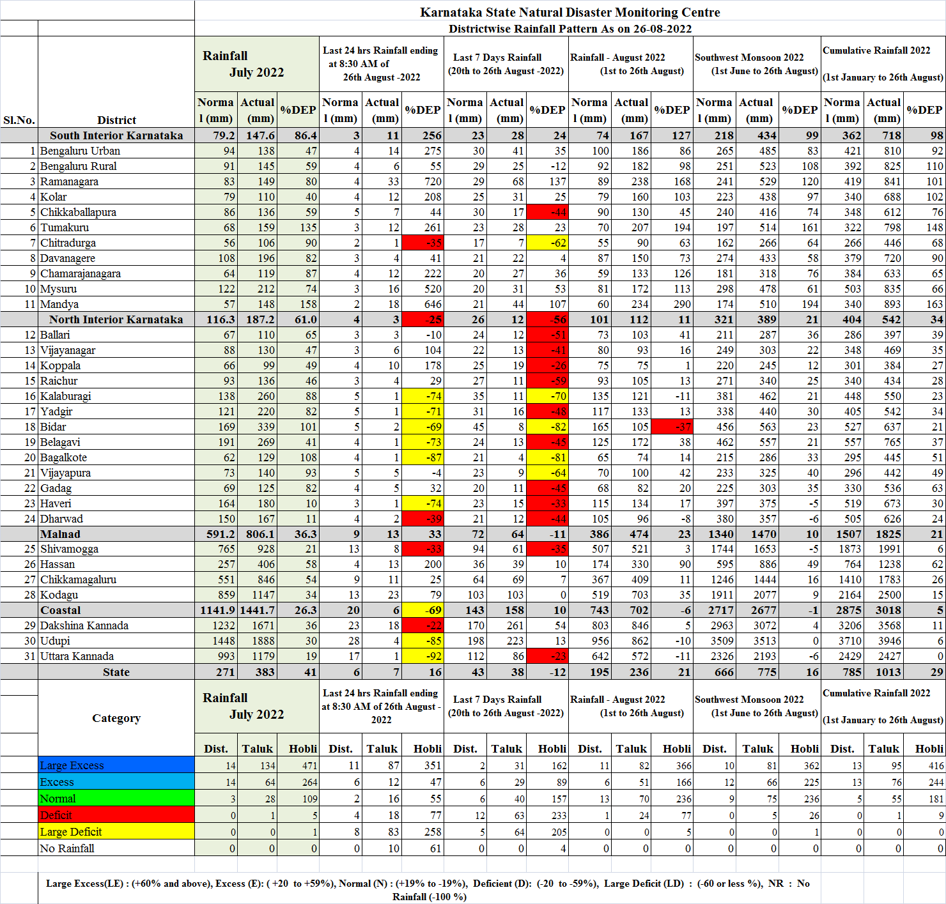
Annexure-2
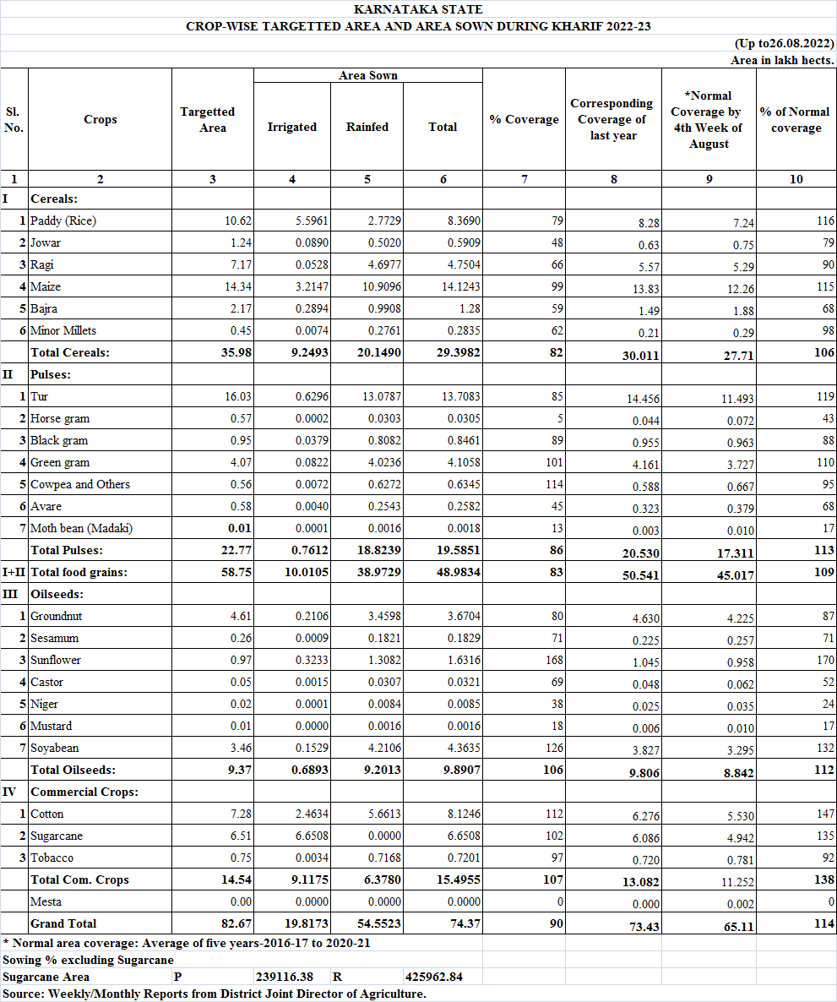
Annexure-3
